Members Sign Up Help & FAQ’s
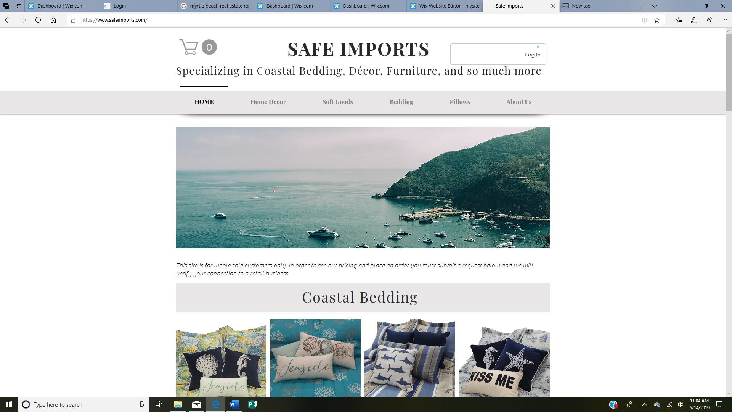
Step #1. Go to www.safeimports.com . It should look like the picture below.

Step #2. Now you want to go to the top right-hand corner of the website and click the button Log In. I have circled it in red in the picture below.

Step #3. Now your screen should look like the picture below.
- New member will fill in the sign-up form. Once you fill in the form you will hit submit and your member ship will then be approved. This may take up to 24hrs. Once it is approved you can log in and use our site.
- Existing member will scroll to the bottom of the page under the sign-up button where it says “Already a member? Log In”. Once your membership has been approved this is also where you will go to log in to the site from now on.
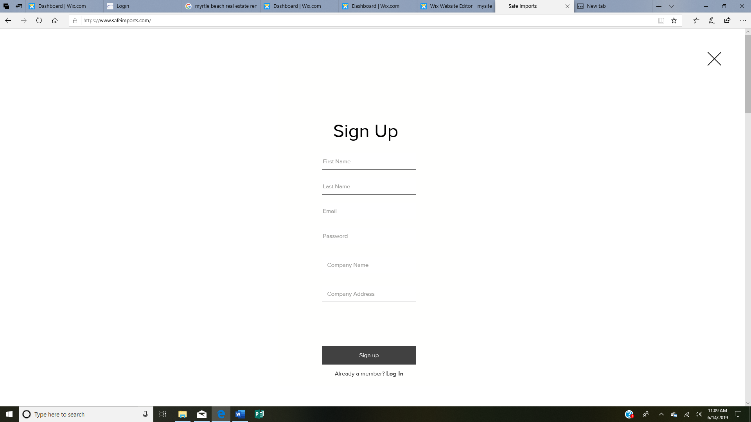

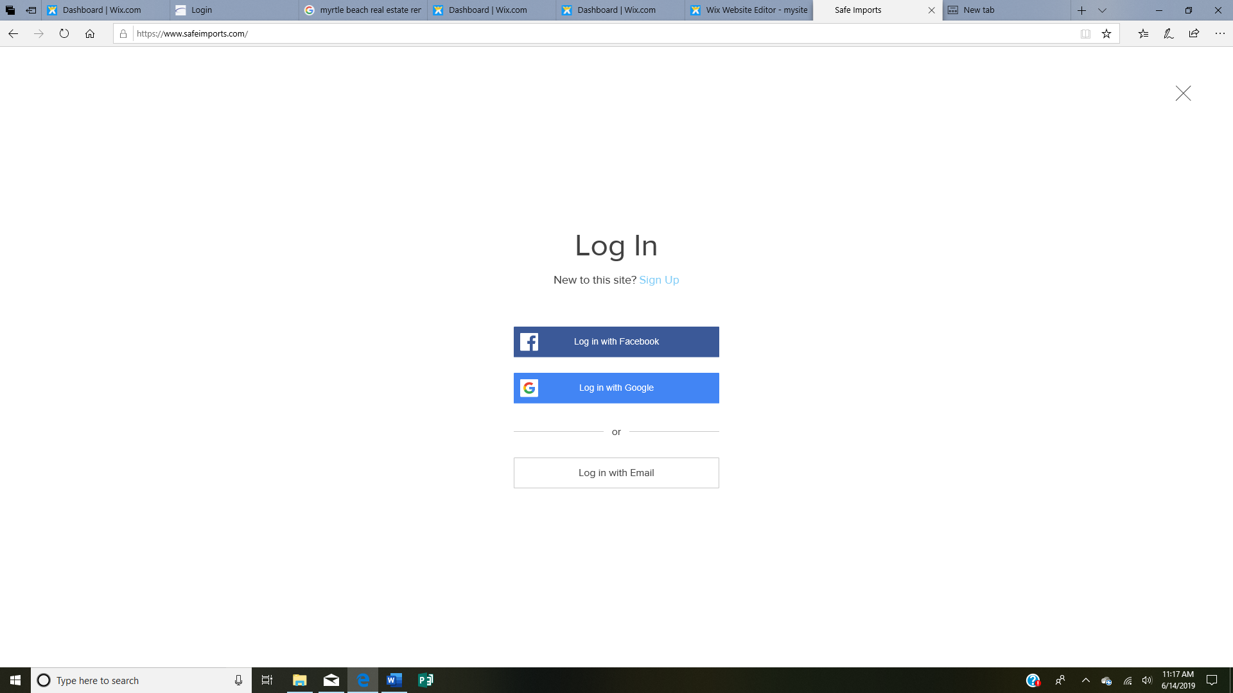
Step #4. The login screen will look like the picture below when you click the red circled Log In button in the picture above. Click the log in with email button.

Step #5. Your next screen will look like the picture below. Type in your email and password that you created when you signed up and the click the blue Log In button.
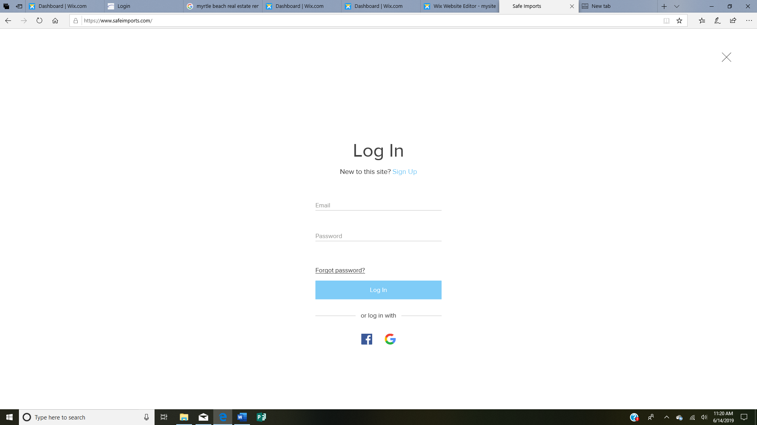

Step #6. Once you click Log In it will then take you back to the website. Sometimes it will take you back to the sign-up screen for a moment and then take you to the website. Don’t touch or click anything, just wait after a few seconds it will take you to our website and it will look like the screen below. You will notice your email address in the box in the top right-hand corner where it use to say “Log In”. This means you are now logged in and can place orders and see prices.
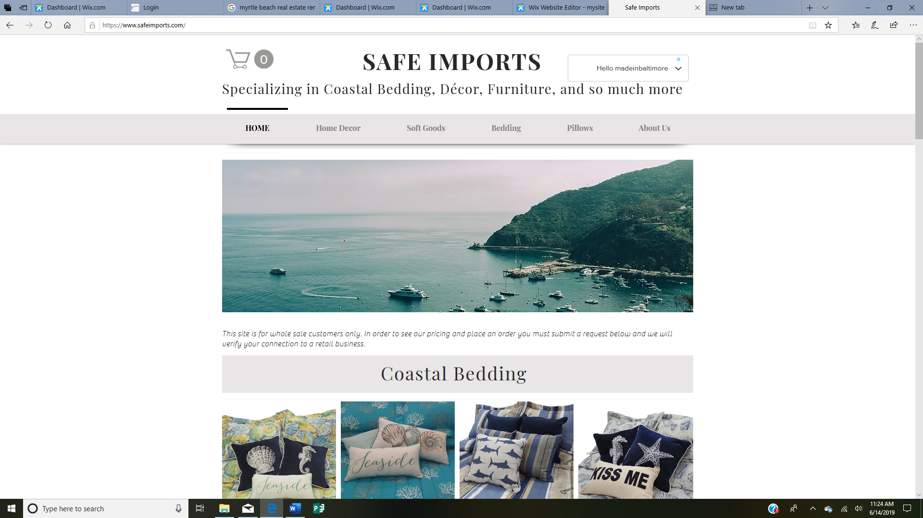

Step #7. Now when you click on the box a drop-down screen will appear allowing you to access the members area. You can see your previous orders placed, add a payment method, update your information and much more.

Step #8. If you click on “My Account” from the drop-down menu it will take you to
The screen to the right. If you notice the box on the left-hand side, there are two links.
One says documents and if you click on that it will take you to our price list and catalog
pages with pictures if you would want to print anything out to let your customers see
products you do not have in store. If you click Current out of stock list, it will take you to
a screen that will show you all the products that are out of stock or that have been
discontinued.
If you have any problems you can always email at tina@safeimports.com or call at
(410) 566-5078

